Department of Electrical Engineering
The Superior University, Lahore

Computer Programming

Experiment No.4
Control Structures and Relational Operators

Prepared for:
Eisha Nawaz
By:
Name: Tanseer Haider
ID: SU91-BSEEM-F25-02
Section: Electrical Engineering Fall 25
Semester: 2nd

Total Marks: _______10________
Obtained Marks: ______________
Signature: __________________
Date: __________________

Experiment No.4
Control Structures and Relational Operators
(Rubrics)

Name: Tanseer Haider ID: SU91-BSEEM-F25-02

- PSYCHOMOTOR
Serial No. | Criteria | Allocated Marks | Unacceptable  0% | Poor  25% | Fair  50% | Good  75% | Excellent  100% | Total Obtained
1 | Follow Procedures | 2 | 0 | 0.5 | 1 | 1.5 | 2
2 | Accuracy in Output Results | 4 | 0 | 1 | 2 | 3 | 4
Sub-Total |  | 6 | Sub Total Marks Obtained in Psychomotor (P)

- AFFECTIVE
Serial No. | Criteria | Allocated Marks | Unacceptable  0% | Poor  25% | Fair  50% | Good  75% | Excellent  100% | Total Obtained
1 | Assigned tasks | 2 | 0 | 0.5 | 1 | 1.5 | 2
2 | Lab Report | 2 | 0 | 0.5 | 1 | 1.5 | 2
Sub-Total |  | 4 | Sub Total Marks Obtained in Affective (A)

Instructor Name: | Miss Eisha Nawaz | Total Marks (P+A): | _____10_______
Instructor Signature: | ______________ | Obtained Marks (P+A): | ______________

Control Structures and Relational Operators

Lab Objectives
- To use relational operators and expressions.
- To use logical operators and expressions.
- To study the nature of the control structures.
- To get basic understanding of nested-if conditions.
- To practice how to use the nested-if.

Introduction to Control Structures
Control structures provide alternatives to sequential program execution and are used to alter the sequential flow of execution. The two most common control structures are selection and repetition.
Control Structures
Selection
Loop/Repetition
For
If-Else
Switch
Do-While
While
Figure 1 Control Structures
The focus of this lab is to study the If-Else control structure. Remaining control structures will be discussed in next labs.

Selection Based Control Structures
In selection, the program executes particular statements depending on some condition(s). The example is shown in Figure 2.
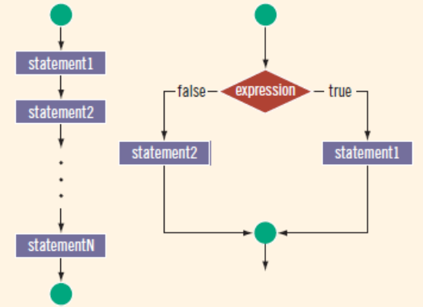
Figure 2 Selection Structure
Before you learn about selection and repetition, you must understand the nature of conditional statements and how to use them.

One Way Selection
It begins with the reserved word if, followed byan expression contained within parentheses, followed by a statement. Note that the parentheses around the expression are part of the syntax. The expression is sometimes called a decision maker because it decides whether to execute the statement that follows it. The expression is usually a logical expression. If the value of the expression is true, the statement executes
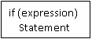

Figure 6

Example
Table 3
 | Code | Result
1 | //Example 1: One Way Selection.cpp  #include<iostream>  using namespace std;  int main()  {  int score;char grade = 'P';  cout<<"Please Enter the score: ";  cin>>score;  cout<<"Your entered score is: "<<score<<endl;  if (score>=60){  cout<<"Your Grade is: "<<grade;  cout<<"Your Grade is: "<<grade;  cout<<"Your Grade is: "<<grade;  }  return 0;  } | Please Enter the score: 60  Your entered score is: 60  Your Grade is: P
2
3
4
5
6
7
8
9
10
11
12
13
14
15

Example
 | Code | Result
1 | //Example 2: Absolute value of an integer  #include <iostream>  using namespace std;  int main()  { int number, abs;  cout<< "Please enter the value of an integer: ";  cin>> number; cout<<endl; abs = number; if (number < 0) number = -number; cout<< "The absolute value of an integer "  << abs << " is: " << number <<endl;  return 0;} | Please Enter the value of an integer: -4555  The absolute value of an integer -4555 is: 4555
2
3
4
5
6
7
8
9
10
11
12
13
14
15
16
17

Two Way Selection
There are many programming situations in which you must choose between two alternatives. For example, if a part-time employee works overtime, the paycheck is calculated using the overtime payment formula; otherwise, the paycheck is calculated using the regular formula. This is an example of two-way selection.that is, to implement two-way selections—C++ provides the if. . . else statement. Two-way selection uses the following syntax:
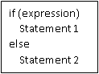
Figure 7
The semicolon at the end of the if statement (see Line 1) ends the if statement, so the statement in Line 2 separates the else clause from the if statement. That is, else is all by itself. Because there is no stand-alone else statement in C++, this code generates a syntax error. In a one-way selection, the semicolon at the end of an if statement is a logical error, whereas as shown in this example, in a two-way selection, it is a syntax error.

Example
The following program determines an employee’s weekly wages. If the hours worked exceed 40, wages include overtime payment.
1 | // Example : Weekly wages  #include <iostream>  using namespace std;  int main ()  { double wages, rate, hours;  cout<< "Please enter your working hours: ";  cin>> hours;  cout<< "Please enter the rate:Rs ";  cin>> rate;  if (hours > 40.0)  wages = 40.0 * rate + (1.5 * rate * (hours - 40.0));  else  wages = hours * rate;  cout<<endl;  cout<< "Your total calculated wage is: Rs " << wages<<endl;  return 0; } | Result
2
3
4
5
6
7
8
9
10
11
12
13
14
15
16
17
18
19
20
21

Relational Operators
C++ includes six relational operators that allow you to state conditions and make comparisons. Each of the relational operators is a binary operator; that is, it requires two operands. Because the result of a comparison is true or false, expressions using these operators evaluate to true or false.
Table 1 Types of Operators in C++
Number of Observations | Operators | Description
1 | = = | Equal to
2 | ! = | Not equal to
3 | < | Less than
4 | < = | Less than or equal to
5 | > | Greater than
6 | >= | Greater than or equal to

Using Operators with Simple Data Types
You can use the relational operators with all three simple data types. In the following example, the expressions use both integers and real numbers:
Table 2
Expression | Meaning | Value
8 < 15 | 8 is less than 15 | True
6 != 6 | 6 is not equal to 6 | False
2.5 > 5.8 | 2.5 is greater than 5.8 | False
5.9 <= 7.5 | 5.9 is less than or equal to 7.5 | True

Logical Operators and Expressions
Logical (Boolean) operators enable you to combine logical expressions. C++ has three logical (Boolean) operators.
Operator | Expression
! | Not
&& | And
| | | Or

Logical operators take only logical values as operands and yield only logical values as results. The operator! is unary, so it has only one operand. The operators && and || are binary operators.
&& Operator (AND)
A | B | a&&b
True | False | False
True | True | True
False | False | False
False | True | False

The operator || corresponds to the Boolean logical operation OR, which yields true if either of its operands is true, thus being false only when both operands are false. Here are the possible results of a||b:
|| Operator (OR)
A | B | a&&b
True | False | True
True | True | True
False | False | False
False | True | True

Order of Precedence
Complex logical expressions can be difficult to evaluate. Consider the following logical expression:
11 > 5 || 6 < 15 && 7 >= 8
This logical expression yields different results, depending on whether || or &&is evaluated first. If || is evaluated first, the expression evaluates to false. If &&is evaluated first, the expression evaluates to true.
5 + 3 <= 9 && 2 > 3
To work with complex logical expressions, given table shows the Precedence Operators
Operators | Precedence
!, ++, -- (unary operators) | First
*, /, % | Second
+, - | Third
<, <=, >=, > | Fourth
==, != | Fifth
&& | Sixth
| | | Seventh

Example 1
Code | Output
//Program to check if a number is greatest among three numbers using logical && operator  int main ()  {  int a,b,c;  cout<<” enter three numbers\n”;  cin>>a>>b>>c;  if (a>b && a>c)  cout<<"A is greatest.\n";  else  cout<<”A is not greatest\n”;  return 0;  } | Enter three number: 15 12 11  A is greatest

Nested If
In the previous lab, you have learned how to use conditions and have learned three different types of conditions (simple if-statement, if-else statement and if-else-if statements, and compound statements). Those statements worked for a single condition; however, there are certain real problems when we need to make the decision based on one two or more conditions. In this case we can use nested-if and will learn in detail about nested-if in this lab.

Flowchart of Nested If
As shown in the given figure, the use of nested if statements help us to check dependency based on the given conditions. For instance, if condition 1 is true then condition 2 will be executed else condition 3 will be executed.
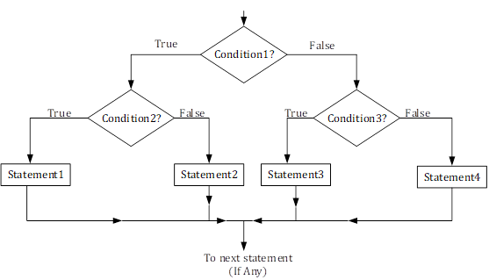
Figure 1 Flowchart of Nested if

Example 1
Code | Output
// Program to check whether we can go to play cricket or not using nested if
#include<iostream>
using namespace std;
int main ()
{ int temperature;
int wind;
int friends;
cout<<"Enter the temperature: "<<endl;
cin>>temperature;
cout<<"Enter the Wind/kmh: "<<endl;
cin>>wind;
cout<<” Enter Number of friends available” <<endl;
cin>>friends;
if (temperature >= 50)
{
cout<< "Temperature is fine" <<endl;
if (wind <= 40)
{
cout<<” Wind is fine.” <<endl;
if(friends>=2)
{
cout<< "There are enough friends" <<endl;
cout<<” We can go to play badminton” <<endl;
}
}
} return 0;}

If…else Ladder
The if...else statement executes two different codes depending upon whether the test expression is true or false. Sometimes, a choice has to be made from more than 2 possibilities.
The if...else ladder allows you to check between multiple test expressions and execute different statements.

Syntax

if (test expression1) {
// statement(s)
}
else if (test expression2) {
// statement(s)
}
else if (test expression3) {
// statement(s)
}
.
.
else {
// statement(s)
}

Example 2
Code | Output
int main()  {  int a,b,c;  cout<<"Enter three number: "<<endl;  cin>>a>>b>>c;  if(a==b && a==c) cout<<"All are equal.\n";  else if(a>b && a>c) cout<<"a is big.\n";  else if(a==b && a>c) cout<<"a & b are big.\n";  else if(b==c && b>a) cout<<"b & c are big.\n";  else if(a==c && a>b) cout<<"a & c are big.\n";  else if(b>c) cout<<"b is big.\n";  else cout<<"c is big.\n";  return 0;  } | Enter three number: 10 15 12  b is big.

Lab Tasks

Task 1:
You are a player entering the Number Quest Arena. To win, you must pass 3 levels by solving number-based challenges. Each level unlocks the next!
🕹️ Level 1: Battle of Numbers
The game asks you to enter two integers.
The system compares them:
- Displays the greater number
- Displays the smaller number

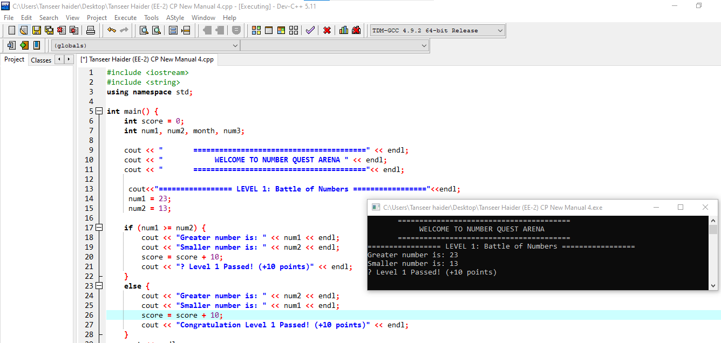
🗓️ Level 2: Month Decoder
- Enter a number between 1–12.
- The system decodes it into a month name:
  - Example: 6 → JUNE
- If the number is invalid → show "Invalid Month" ❌
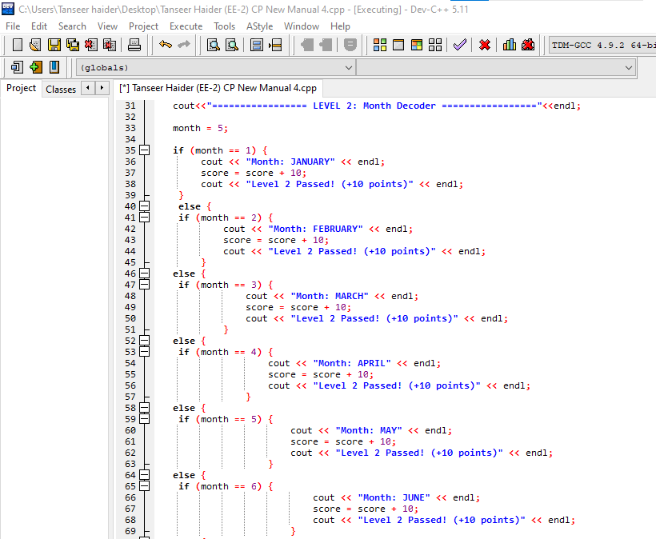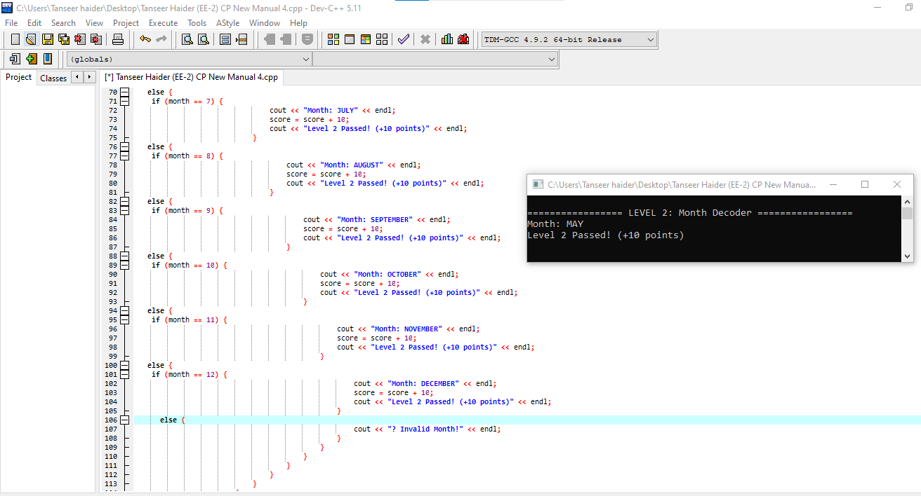
🔢 Level 3: Divisibility Challenge
- Enter a number.
- Check:
  - If divisible by 3
    - Then also check if divisible by 4
- Otherwise → display "Not divisible by 3"
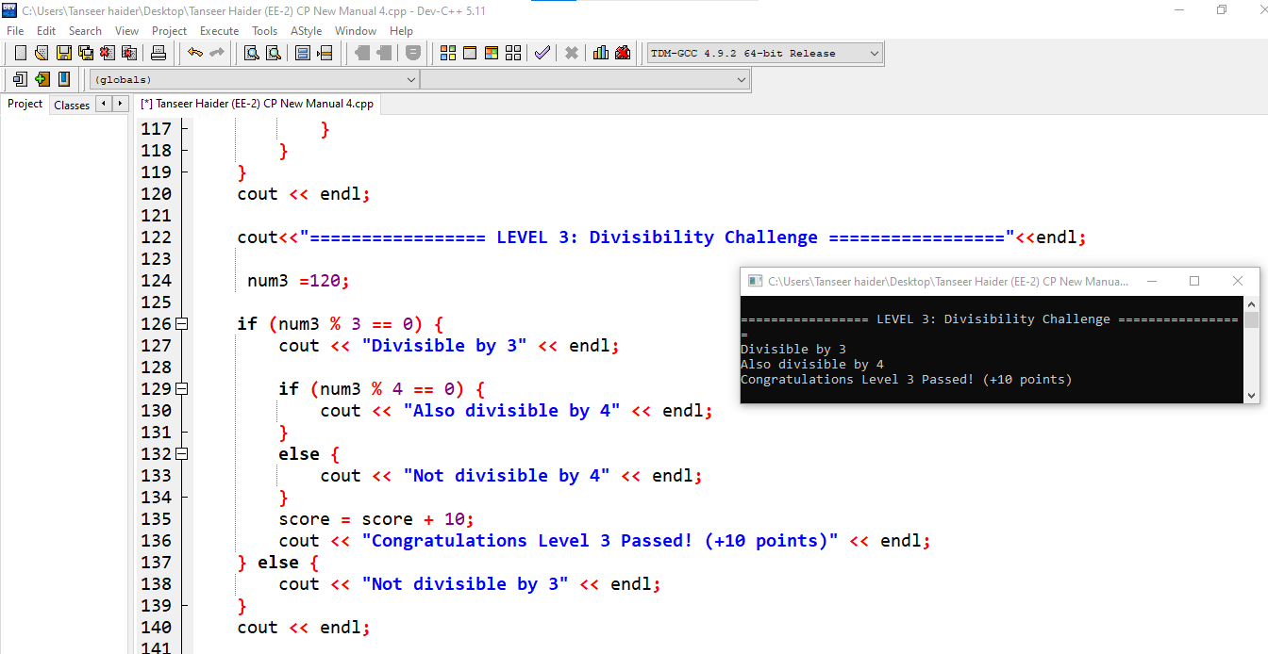
⭐ Bonus Feature (Game Flavor)
- Keep a score counter:
  - +10 points for each correct level input
- Display final score at the end
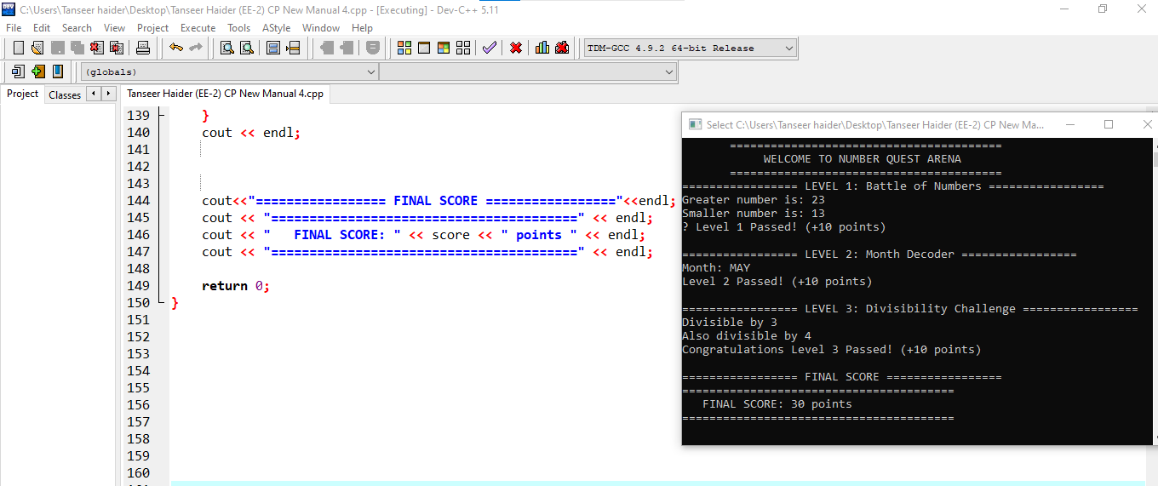
Home Assignment:

Task 1:
Ultimate Logic Arena
- Show at the start of the output screen.
“Welcome to the Ultimate Logic Arena”
You must pass 5 levels to become the Logic Champion. Each level tests a different concept of if–else control structures.
👑 Level 1: The Number King
- Enter five numbers.
- Using nested if–else, find and display the largest number.
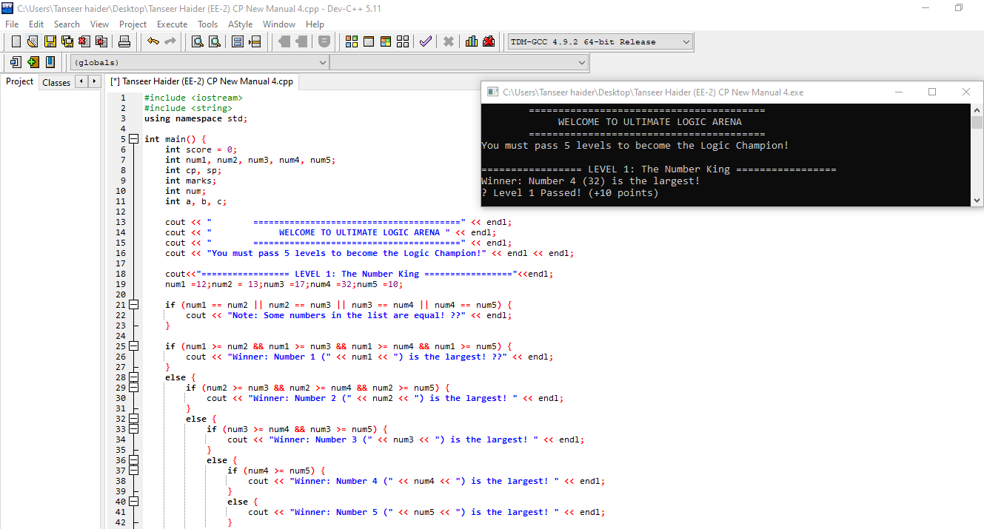
💰 Level 2: Trade Master
- Enter:
  - Cost Price (CP)
  - Selling Price (SP)
- Determine:
  - If profit → display amount
  - If loss → display amount
  - If equal → display "No Profit No Loss"
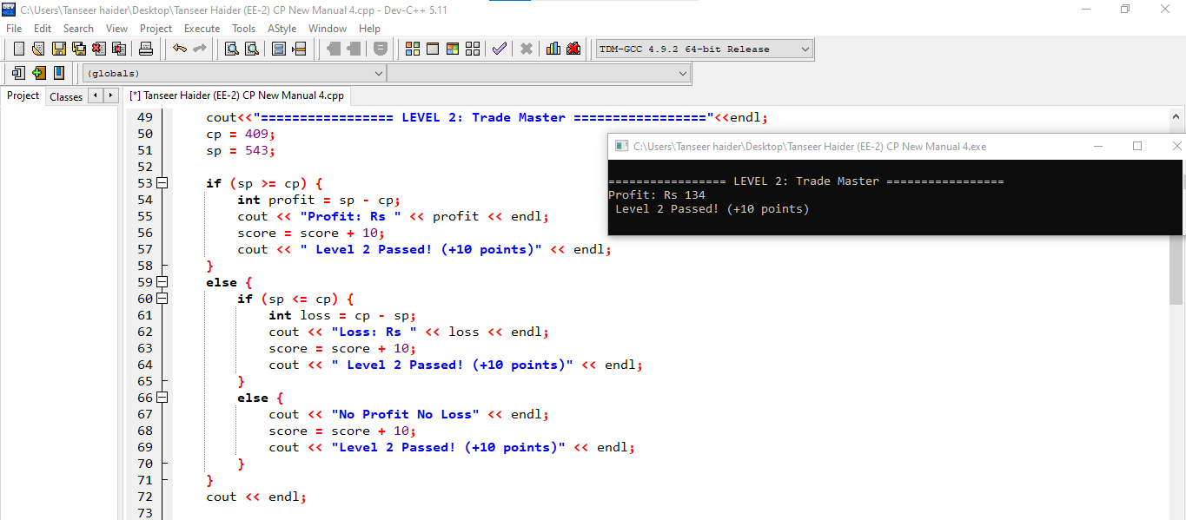

🎓 Level 3: Grade Evaluator
- Enter student marks (0–100).
- Assign grade using if–else ladder:
Marks Range | Grade
< 50 | F
50–59 | C
60–69 | B
70–79 | B+
80–89 | A
90–100 | A+
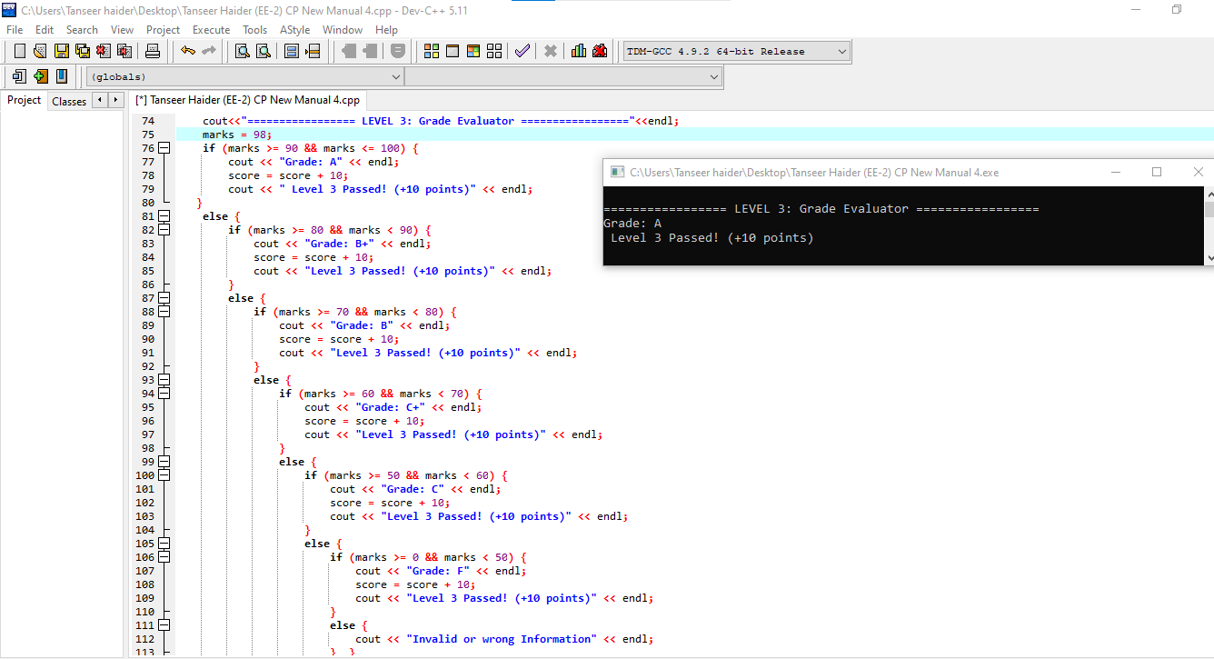
⚙️ Level 4: Number Analyzer
- Enter an integer:
  - Check if Even or Odd
  - Check if Divisible by 4
  - Display remainder when divided by 3
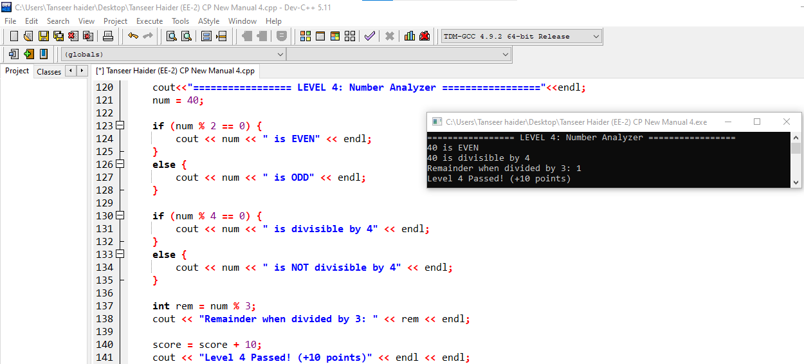
🔺 Level 5: Triple Threat
- Enter three numbers
- Find:
  - Largest number
  - Smallest number
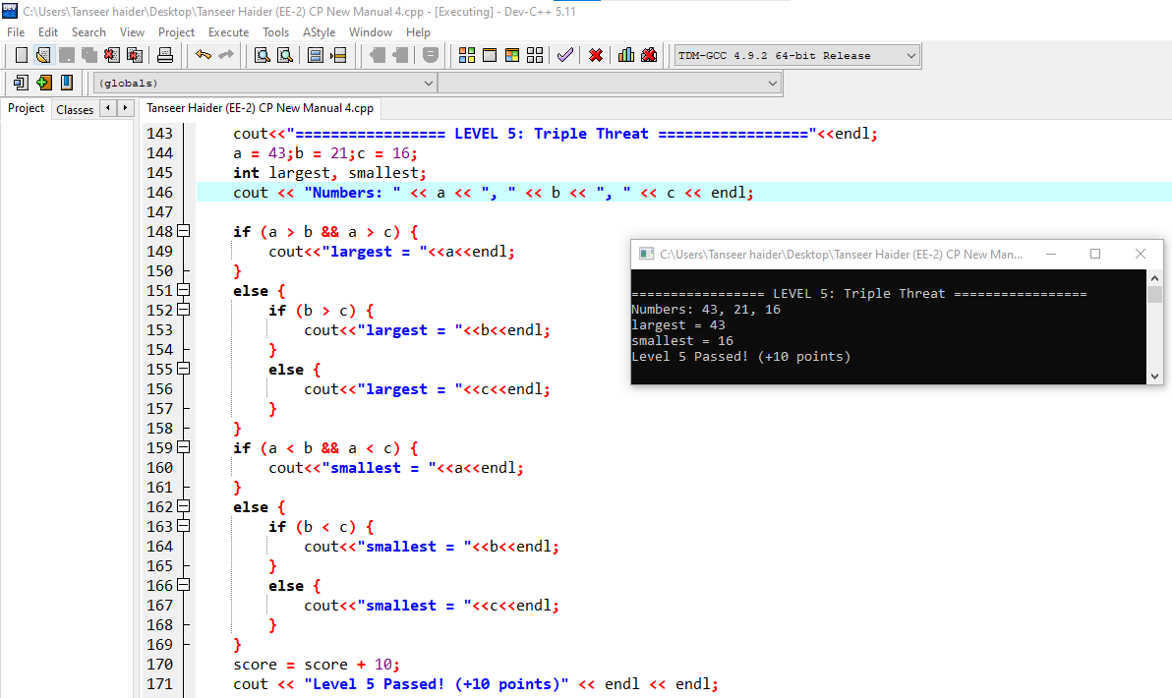
⭐ Bonus Game Feature
- Score system:
  - +10 points per level
- Final title:
  - 50 → Logic Champion
  - 30–40 → Skilled Player
  - <30 → Try Again
